**EXPERIMENT 5**

**DDL COMMANDS (COLLEGE SCHEMA)**

**Aim:**

* Create a schema called College.
* Create tables for students (attributes: student id, name, gender, subject, marks and grade), faculty (attributes: faculty id, name, course and pass percentage), department (attributes: department id, name, section, strength and pass percentage) and activity (attributes: activity id, name, strength and category)
* Add and modify:

Address in students table, change datatype size of student name and make student id primary key

* Add faculty total mentor details, make faculty id as primary key
* Add number of students in wise in department table and make department id as primary key
* Add faculty name to activity table, change the datatype size of activity name and make activity id as primary key

**Code:**

CREATE SCHEMA BVRITH19wh1a0557;

CREATE TABLE student(std_no INTEGER, std_name varchar(20),gender varchar(10),subject varchar(20), marks INTEGER,grade varchar(10));

CREATE TABLE faculty(fac_id INTEGER,fac_name varchar(20),course varchar(20),pass_percent INTEGER);

CREATE TABLE department(dept_no INTEGER, dept_name varchar(20),section varchar(10),no_of_stud INTEGER,pass_percent INTEGER);

CREATE TABLE activity(act_id INTEGER,act_name varchar(20),no_of_stud_opt INTEGER,category varchar(20));

desc student;

desc faculty;

desc department;

desc activity;

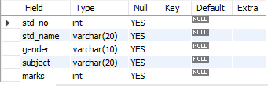

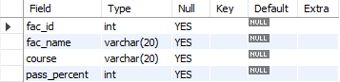

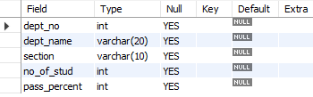

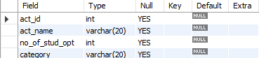

ALTER TABLE student ADD(Address varchar(40), PRIMARY KEY(std_no));

ALTER TABLE student MODIFY std_name varchar(30);

ALTER TABLE faculty ADD(Mentor_details varchar(40), PRIMARY KEY(fac_id));

ALTER TABLE department ADD(No_of_stud_wise INTEGER ,PRIMARY KEY(dept_no));

ALTER TABLE activity MODIFY act_name varchar(30);

ALTER TABLE Activity ADD(fac_name varchar(30),PRIMARY KEY(act_id));

Alter table student rename column std_no to stud_no;

Alter table student drop gender;

desc student;

desc faculty;

desc department;

desc activity;

